
ML PROJECT
I220589_Asad Ullah


Contents
Project Report 1
Problem Statement 2
Objective 2
Phases of the Project 2
Phase 1: Data Preprocessing and Feature Engineering 2
Data Integration 2
Data Cleaning and Transformation 2
Feature Engineering 2
Phase 2: Exploratory Data Analysis (EDA) 3
Visualizations 3
Correlation Analysis 3
Phase 3: Analytical and Predictive Tasks 5
Classification Tasks 5
Regression Analysis 5
Phase 4: Model Optimization and Evaluation 5
Hyperparameter Tuning 5
Validation 5
Model Comparison 5
Phase 5: Model Testing 5
Prediction on Test Dataset 5
Kaggle Submission 6
Conclusion 7

Project Report
Project Title: Flight Departure Delay Prediction

Problem Statement
Flight departure delays are a critical challenge in the aviation industry. Such delays affect passenger satisfaction, airline operations, and overall efficiency. Using provided datasets (train, test, and weather data), the objective is to calculate and predict departure delays. The project includes analyzing delay patterns, building predictive models, and submitting predictions to Kaggle competitions.

Objective
The primary goal of this project is to predict departure delays for flights in the test dataset. The specific objectives are:
- Analyze the train, test, and weather datasets.
- Build predictive models based on the training data.
- Generate predictions for the test data.
- Submit predictions to Kaggle competitions for evaluation.

Phases of the Project

Phase 1: Data Preprocessing and Feature Engineering

Data Integration
  - All the csv files of weather are preprocessed and saved into new files

Data Cleaning and Transformation
  - Handled missing values in both train and weather datasets.
  - Converted time fields into a standard datetime format for consistency.

Feature Engineering
  - Calculated departure delays using scheduled and actual departure times.
  - Extracted relevant weather features such as temperature and wind speed.
  - Derived temporal features including:
    - Day of the week (e.g., Monday, Tuesday).
    - Hour of the day.
    - Month of the year.

Phase 2: Exploratory Data Analysis (EDA)

Visualizations
  - Delay Distributions:
    - Created histograms showing the distribution of delay durations.
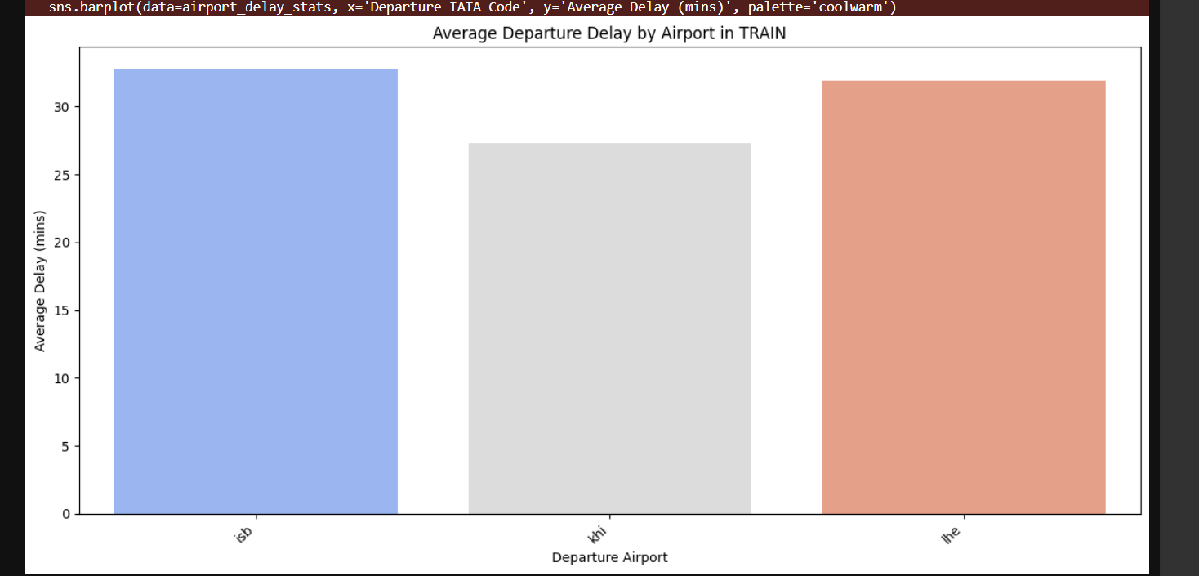
  - Category-Wise Analysis:
    - Analyzed delays by airline, departure airport, and flight status.

Correlation Analysis
  - Visualized relationships between weather conditions and flight delays using scatter plots, heatmaps, and bar charts.
  - 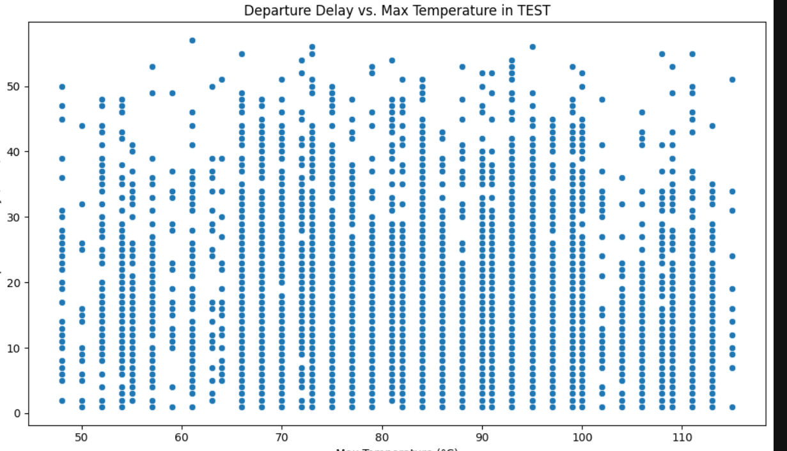
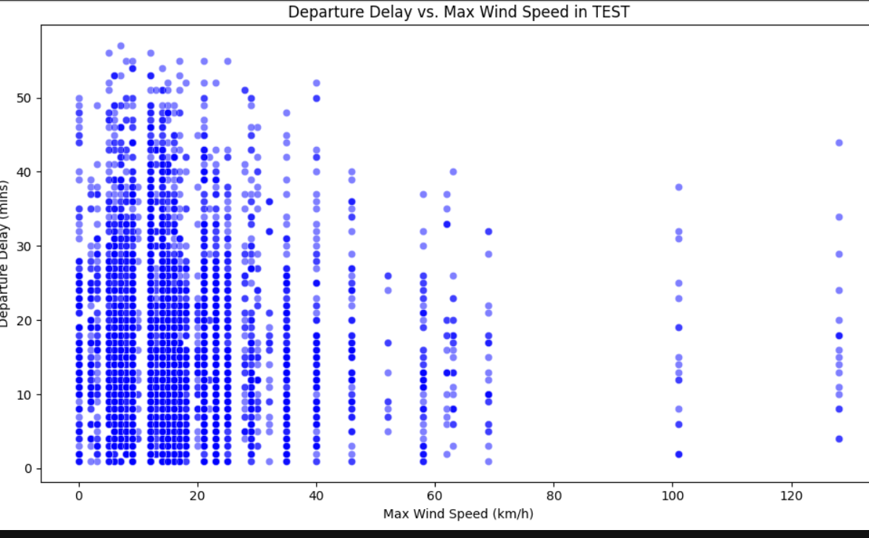

Phase 3: Analytical and Predictive Tasks

Classification Tasks
  - Binary Classification:

  - Multi-Class Classification:

Regression Analysis

Phase 4: Model Optimization and Evaluation

Hyperparameter Tuning
  - Applied grid search and random search techniques to optimize model parameters.

Validation
  - Used k-fold cross-validation to assess model performance and ensure robustness.

Model Comparison
  - Compared performance metrics of different models to select the best-performing ones.

Phase 5: Model Testing

Prediction on Test Dataset
  - Used trained models to make predictions on the test dataset.
  - Saved predictions in Kaggle submission format.

Kaggle Submission
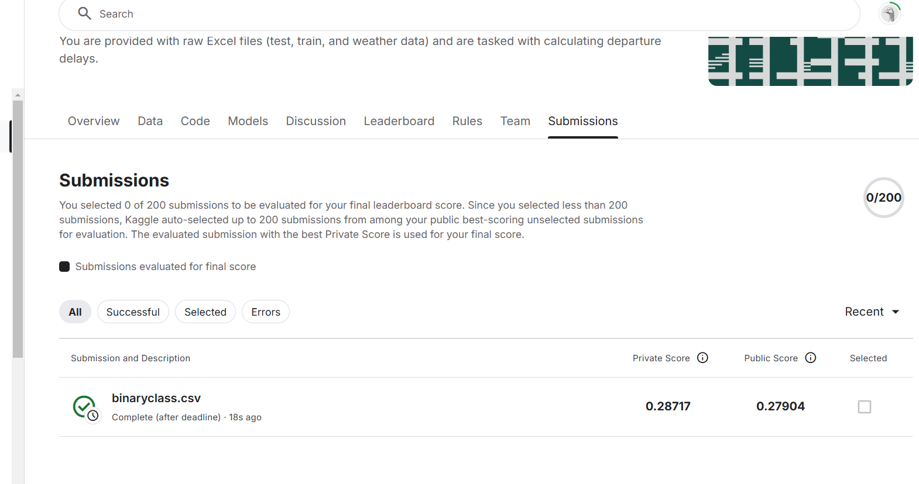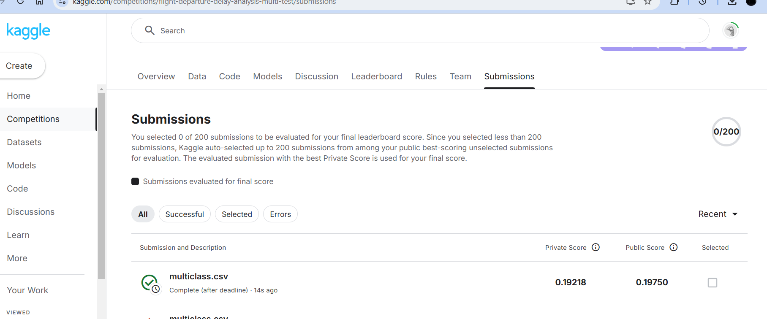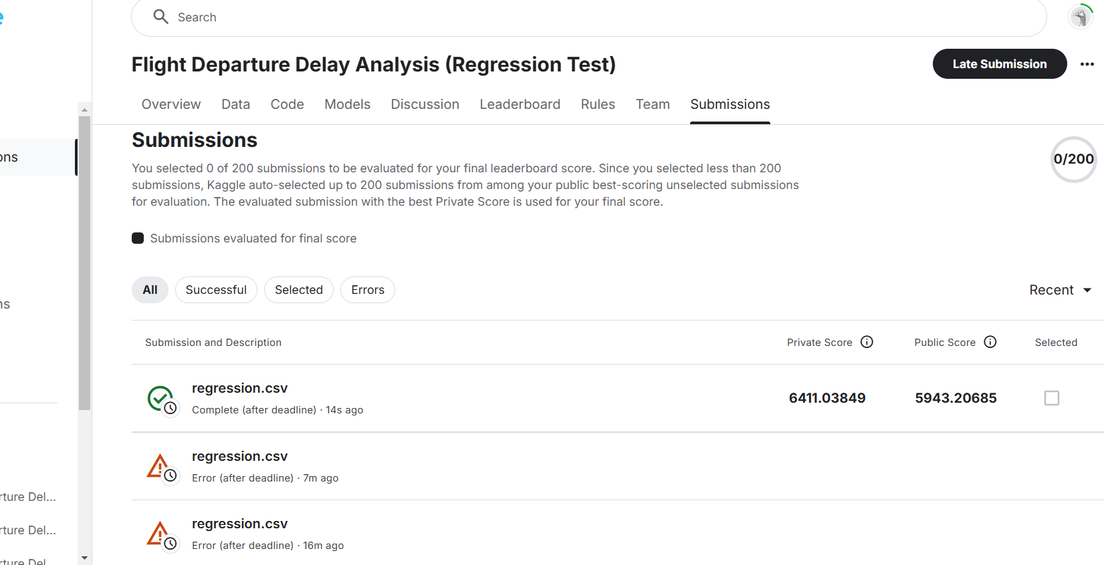

Conclusion
This project successfully analyzed flight departure delays and built predictive models to forecast delays. The binary classification, multi-class classification, and regression models demonstrated significant predictive power and provided insights into key factors influencing delays. The predictions were successfully submitted to Kaggle competitions for evaluation, contributing to a better understanding of delay patterns in the aviation industry.

